New Acquisitions – March 2024  University Library at ISS  Print Books E-books Journals DVDs | 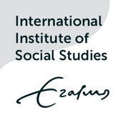
Click on the book covers to see the records in sEURch
Print books:  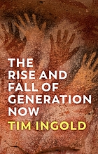  Ingold, T. (2024) The rise and fall of generation now. Cambridge: Polity Press.  Call number: 71244  _____________________  ʿIbādī, S. (2017) Until we are free : my fight for human rights in Iran. London: Rider Books.  Call number: 71249 | 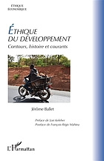  Ballet, J., Keleher, L. and Mahieu, F.-R. (2023) Éthique du développement : contours, histoire et courants. Paris: L’Harmattan.  Call number: 71248  _____________________  Glover, J. (2024) Israelis and Palestinians : from the cycle of violence to the conversation of mankind. Cambridge: Polity Press.  Call number: 71251 | Wind, M. (2024) Towers of ivory and steel : how Israeli universities deny Palestinian freedom. London: Verso.  Call number: 71247  ____________________  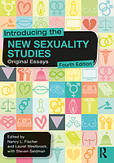  Fischer, N., Westbrook, L. and Seidman, S. (eds.) (2022) Introducing the new sexuality studies : original essays. Fourth edition. Abingdon, Oxon: Routledge, Taylor & Francis Group.  Call number: 71252 | Muḥammadī, N. et al. (2023) White torture : interviews with Iranian women prisoners. . Translated by A. Rezanezhad. London: Oneworld.  Call number: 71250  _____________________  E-books:  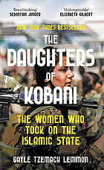  Lemmon, G.T. (2021) The daughters of Kobani : the women who took on the Islamic State. London: Swift Press.
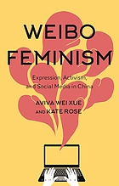  Wei Xue, A. and Rose, K. (2022) Weibo feminism : expression, activism, and social media in China. [London]: [Bloomsbury Academic].  _____________________  Rush, E.A. (2023) The quickening creation and community at the ends of the Earth. Lightning Source (Tier 4). | 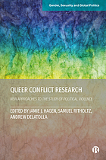  Queer conflict research : new approaches to the study of political violence (2024). Bristol, UK: Bristol University Press.  _____________________  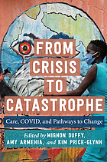  Duffy, M., Armenia, A. and Price-Glynn, K. (eds.) (2023) From crisis to catastrophe : care, COVID, and pathways to change. New Brunswick, New Jersey: Rutgers University Press. | 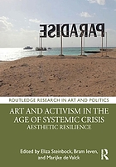  Steinbock, E., Ieven, B. and Valck, M.d. (eds.) (2021) Art and activism in the age of systemic crisis : aesthetic resilience. New York: Routledge.  _____________________  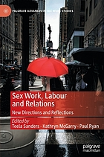  Sanders, T., McGarry, K. and Ryan, P. (eds.) (2022) Sex work, labour and relations : new directions and reflections. Cham: Palgrave Macmillan. | 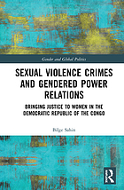  Sahin, B. (2021) Sexual violence crimes and gendered power relations : bringing justice to women in the Democratic Republic of the Congo. Abingdon, Oxon: Routledge.  _____________________  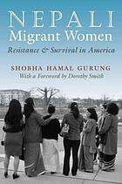  Gurung, S. (2015) Nepali migrant women : resistance and survival in America. First edition. Syracuse, New York: Syracuse University Press

